CACTUS COURIER
Newsletter of the Palomar Cactus and Succulent Society
The North San Diego County Cactus and Succulent Club
Volume 68, Number 10 October 2022

2022 Show & Sale Recap
By Charlyne Barad
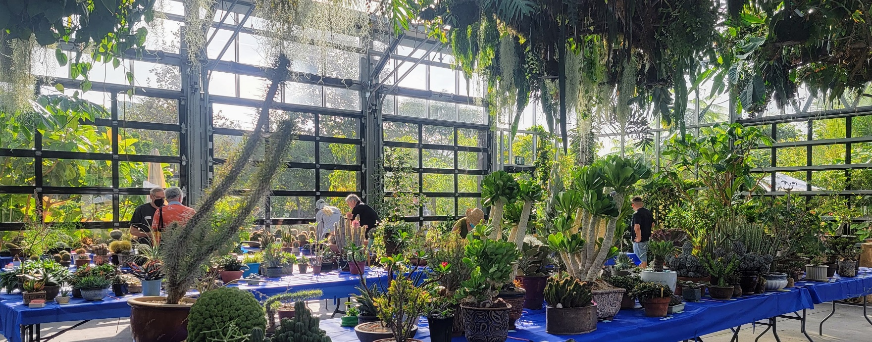
What a wonderful event we had overall, and WOW, what a show!
All of you made it a stunning success by bringing in 344 fascinating plants beautifully staged and in full glory! The diversity of plants was most impressive with something new at every turn!
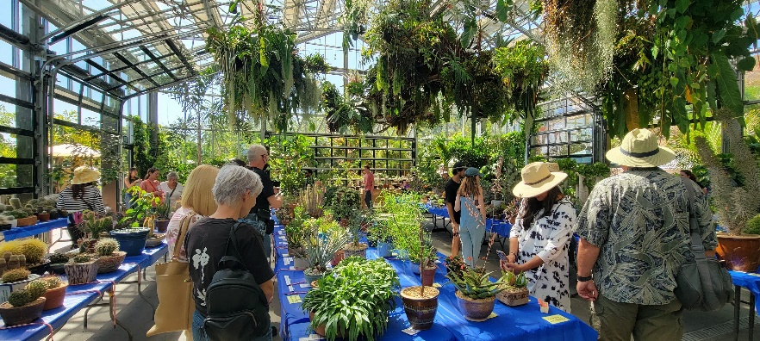
What a joy it was to see them displayed in the San Diego Botanical Garden’s magnificent conservatory! It was a venue truly worthy of your spectacular plants!
Our numerous visitors were exceedingly impressed. Their “oohs,” “ahhhs,” and “wows!” filled the room amid the buzz of excitement. There were many exclamations of, “I’ve never seen anything like this before!” or simply, “Wow, what is that?!”
Volunteers, you were incredible and kept everything running smoothly! Thank you all! (See below for details.) The forty or so of you who were in the thick of it know that such a huge event would never happen without your participation!
Many thanks to our vendors, and to Tina Zucker who coordinated them. There was an abundance of irresistible cactus and succulent plants, pottery, rocks, top dressings, and topiaries to tempt enthusiastic shoppers and collectors of all levels. Those of us manning the cash registers and credit card scanners, and boxing plants were sorely tempted (and succumbed) to the fabulous variety of plants and pots that came through our stations!
Sales were extra brisk, with long lines of shoppers waiting to buy their new treasures. We even garnered some new members among shoppers and guests who were excited by our sales and show.

HUGE thanks to Brita Miller for coordinating the event and to
Dean Karras for managing the show! Bravo to you both!
Thank you, wonderful volunteers!
It wouldn’t have happened without you!

By Charlyne Barad, assistant to event chair
- Setup and/or Breakdown - Kevin Smith, Jim Anderson, Robert Kopfstein, Liz Rozycki,
Patty and Mike Nelson, Dean Karras, Annie Morgan, Pauline Wong, Brita Miller, Lorie Johansen, Charlyne Barad, May Fong Ho, and many others prepared and dismantled the show.
- Vendors - Tina Zucker as the Vendor Chair coordinated with all the vendors. Tina somehow was magically able to get the Sales Area tables and pop-up tents to all fit in despite some serious pre-setup worries.
- Sales – Ken Brown and Winston Chan were lead cashiers, along with Teri Shusterman, Russel Ray, Michelle Leung, John Barkley, Lois Walag, and Charlyne Barad, as the rest of the cashiering team. Harold Dunn, Sherman Blench, Libbi Salvo, Joan Herskowitz, Maxine Hesse, and Heather Chan boxed plants and in general helped our many customers. Pam Dunlap, Barbara Raab, Pauline Wong, and Christa Stringham did a wonderful job manning the Sales area holding tables. And of course, our treasurer, Teri Shusterman, handled all monies, made the payments, did all the record keeping, etc. And to Sherman and Brita for making multiple runs for Costco boxes.
- Thanks to San Diego Cactus and Succulent Society for the use of their cash register. Very special
thanks to Ken Brown, member of SDCSS, for bringing their register and programming both theirs
and our registers on Friday, and for manning a register during most of the weekend. Ken also
downloaded the data from both registers after the sale.
- Security - Tom McCarter, Gloria Kendall, Keith Umbreit, Libbi Salvo, Patty Nelson,
Bill Modi, May-Fong Ho, and Bruce Barry worked to provide security in the sales areas.
Richard Miller provided additional security in the showroom.
- Show - Dean Karras, David Buffington, Mike Nelson, Robert Kopfstein, and Annie Morgan
helped with plant ID. Show clerking and other show needs (including: place tablecloths, divider ropes, category tags, check entry cards, tear off card stubs, etc.) were done by Liz Rozycki, Annie Morgan, Mike Nelson, Brita Miller, and Charlyne Barad.
- Judges - Thanks to our very informative judges, Michael Buckner and Dr. Ed Nelson. We learned a lot from them about what they look for in plant characteristics, growing, and staging. (Did you know we are the only club that permits people in the room to listen as our judges work? What a great way to learn from their expertise!)
- Welcome & Membership - Moni Waiblinger and Chris Barkley did a fantastic job welcoming people and taking care of the Membership Table.
- Refreshments - Lorie Johansen, Barbara Raab, and Sandy Wetzel-Smith took care of the food and refreshments so that our volunteers, vendors, and members didn’t go hungry. Huge thanks to everyone who brought in all the delicious food that kept us going all weekend!
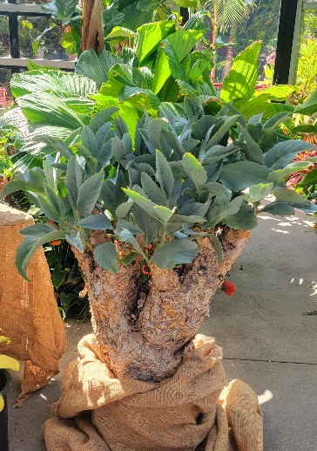
- Various Jobs - Our president, Robert Kopfstein, who volunteers at SDBG, communicated with the Garden to make arrangements for use of their facility. Robert spread the word to other garden clubs, and Lorie Johansen worked as event photographer. Dean Karras and David Buffington compiled the list of plant categories and printed the category labels for the tables. David will also tally entry card stubs to award prize plants at the holiday party in December. Moni Waiblinger, Prapa Taylor, and many other volunteers encouraged visitors to complete People’s Choice ballots. Dean Karras tallied those ballots. Richard Miller spent a lot of time cutting and scoring entry cards before the show. Many others were great at helping with all the other various jobs that came up as the event went along. Deepest thanks to all!
- San Diego Botanic Garden - For publicizing our event. A large percentage of the public that came to our event heard about it through the Garden. Thanks to the Garden for the use of their magnificent conservatory, their tables in the showroom, the help of their volunteers to perform security in the showroom, and for a most impressive display of their plants! The display at the back of the room was set up just for us!
- Everyone Who Brought Plants - Thank you, everyone, for sharing your glorious plants! At one point, Brita and I were worried that we might not get enough plants to fill the larger room. Hah! We ended up adding seven tables to accommodate all the wonderful plants that you brought!

Sorry if I’ve missed thanking someone. Your help was greatly appreciated!!!

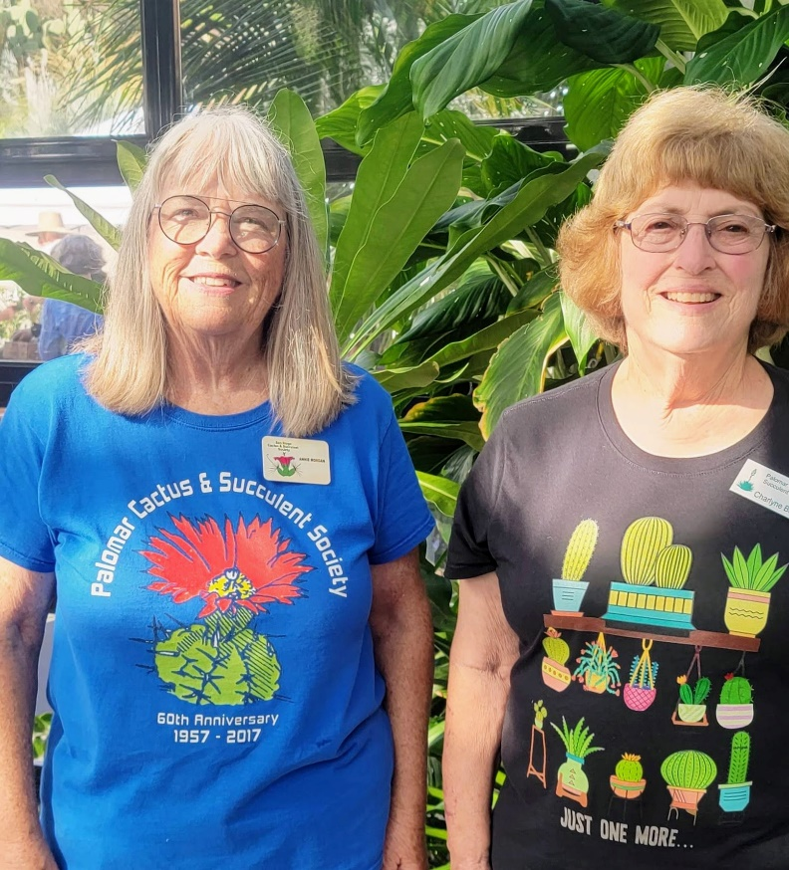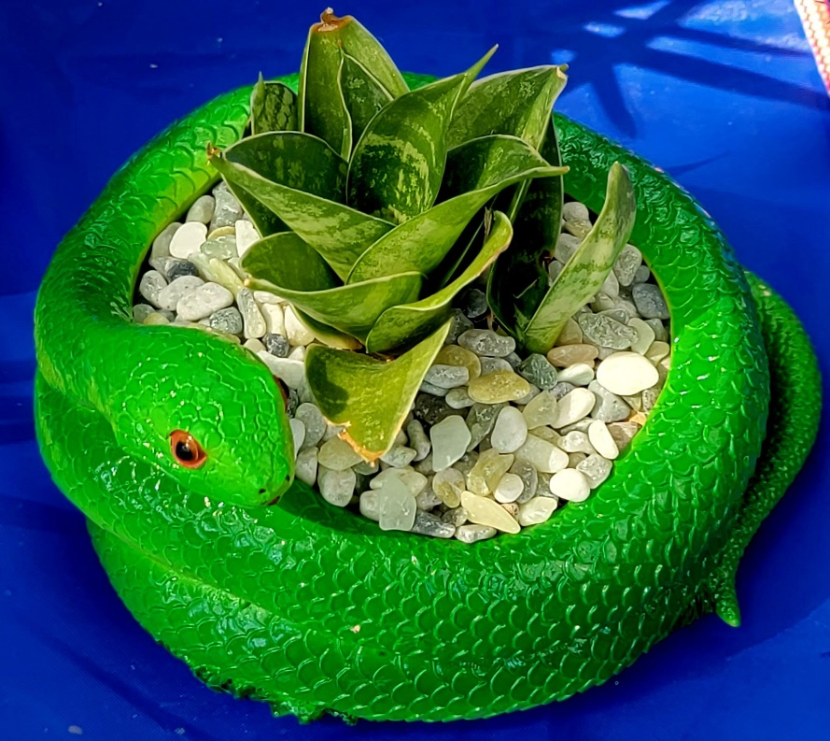
Sansevieria hahnii (snake plant) in a snake planter, by Russel Ray.
Annie Morgan and Charlyne Barad.
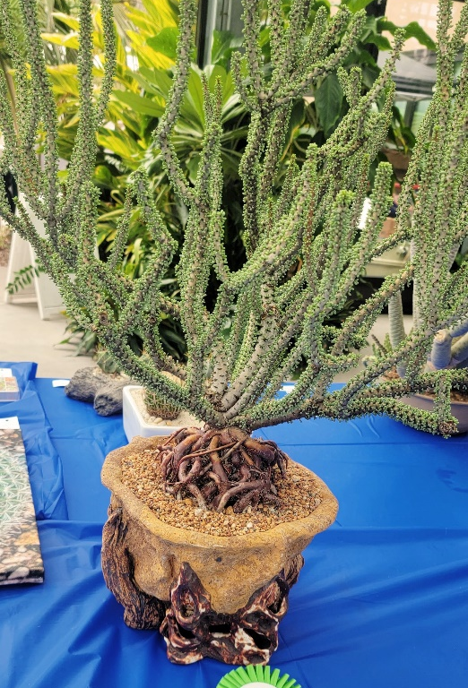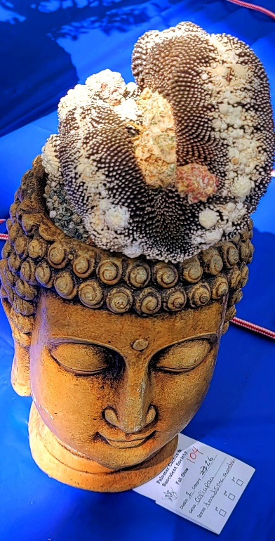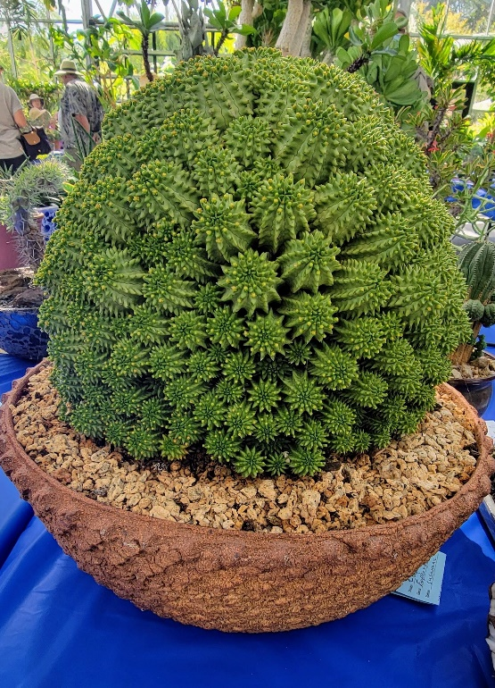
People’s Choice
Ceraria namaquensis
by Peter Walkowiak
Euphorbia suzannae
by Peter Walkowiak.
Copiapoa tenuissima f. monstruosa
by Dr. Cactus.
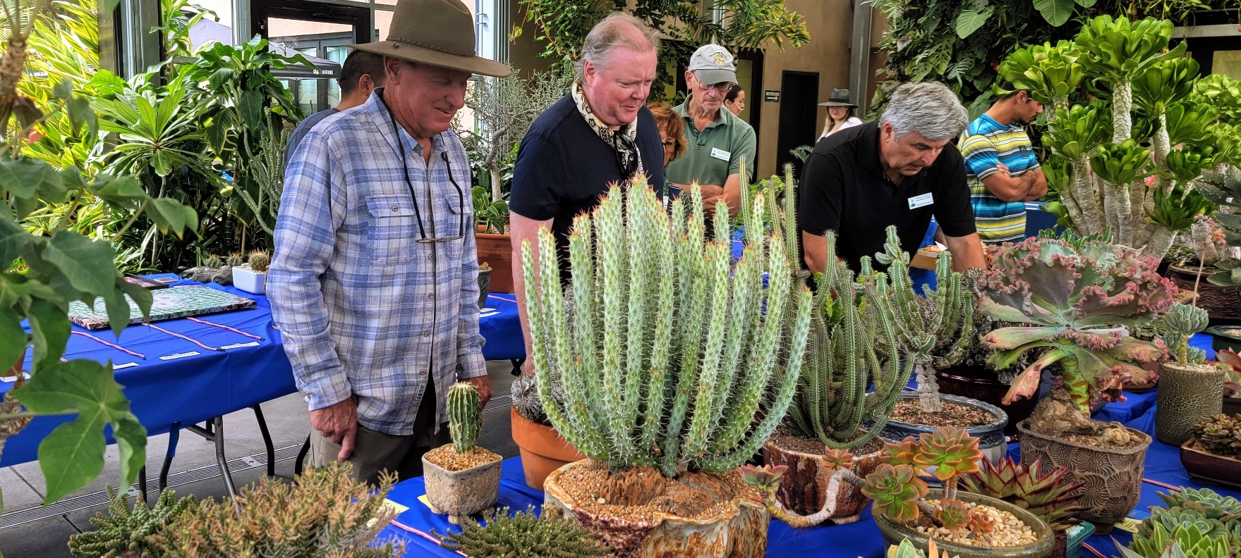
Judges judging: Michael Buckner (left) and Dr. Ed Nelson.
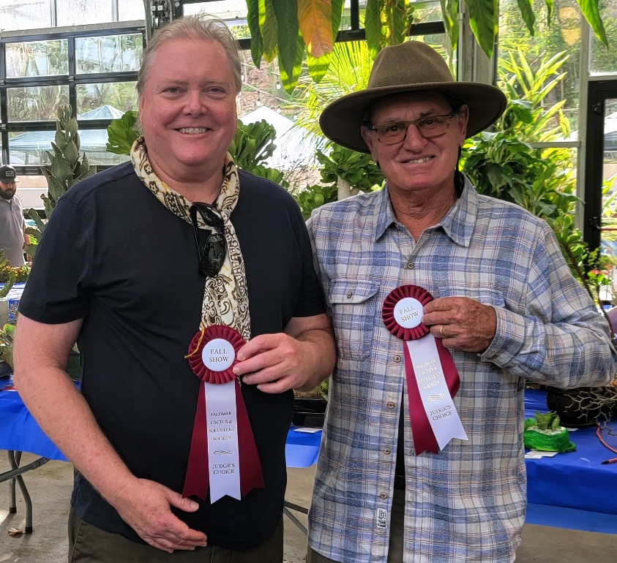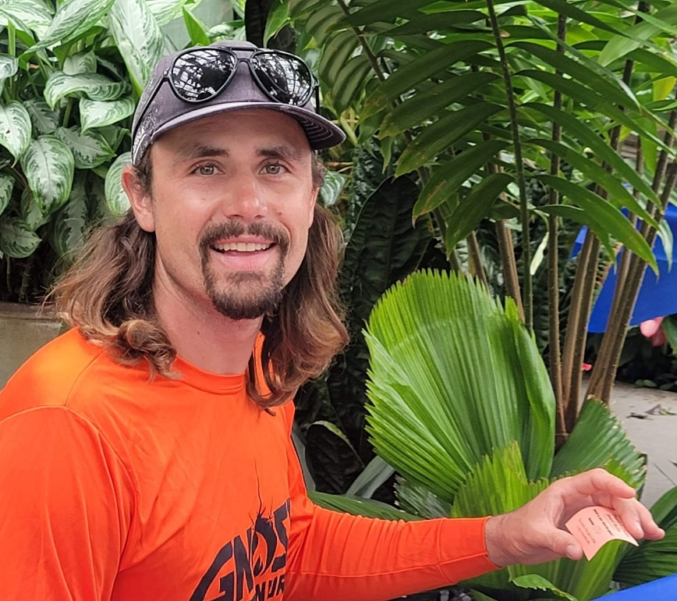
Show Chair: Dean Karras, owner of Gnosis Nursery
Judges: Dr. Ed Nelson (left) and Michael Buckner
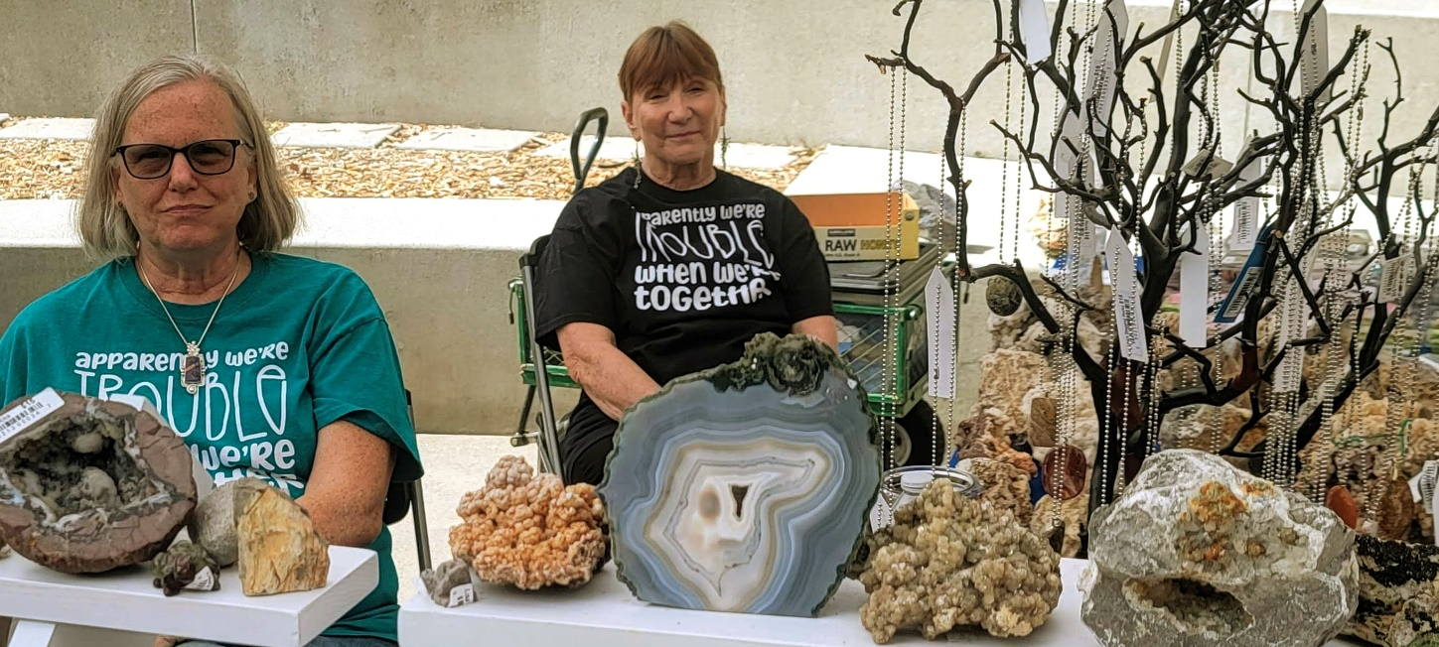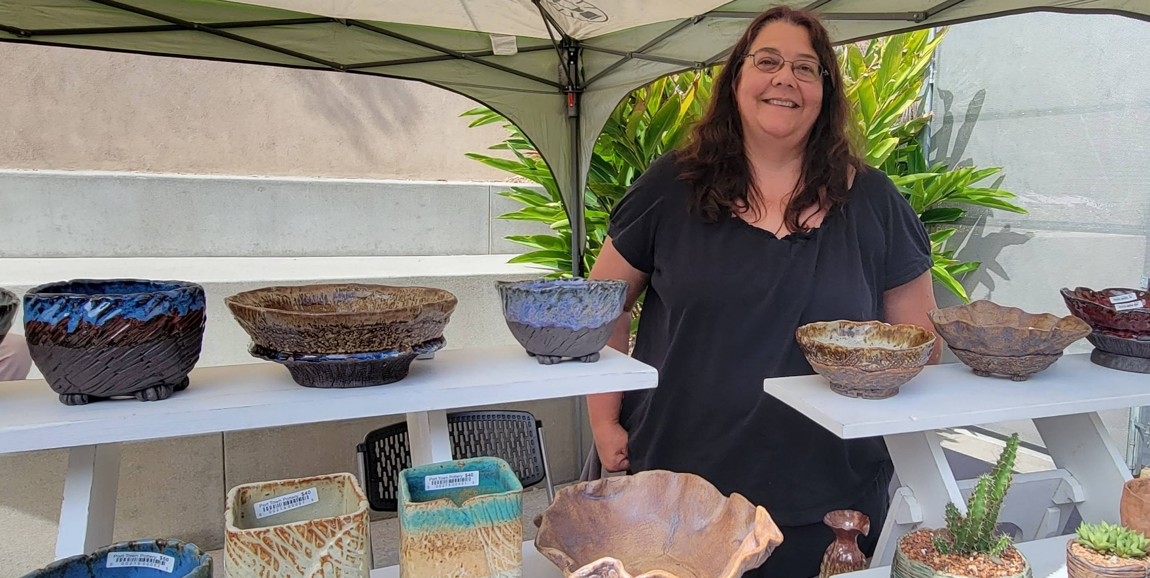
Lisa Brosseau (left) and Diane Brantley of Lisa Rocks.
Regina Fernandez, owner of Port Town Pottery.
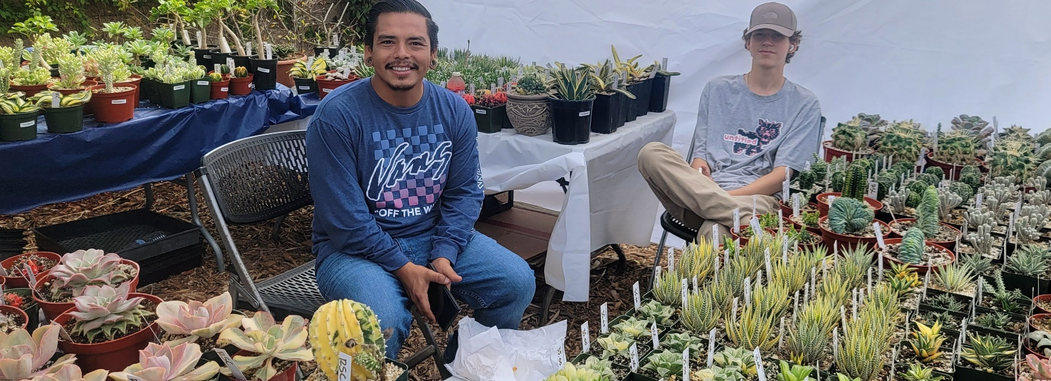
Carlos Zavaleta, owner of Rojas Succulents, and son Noah.
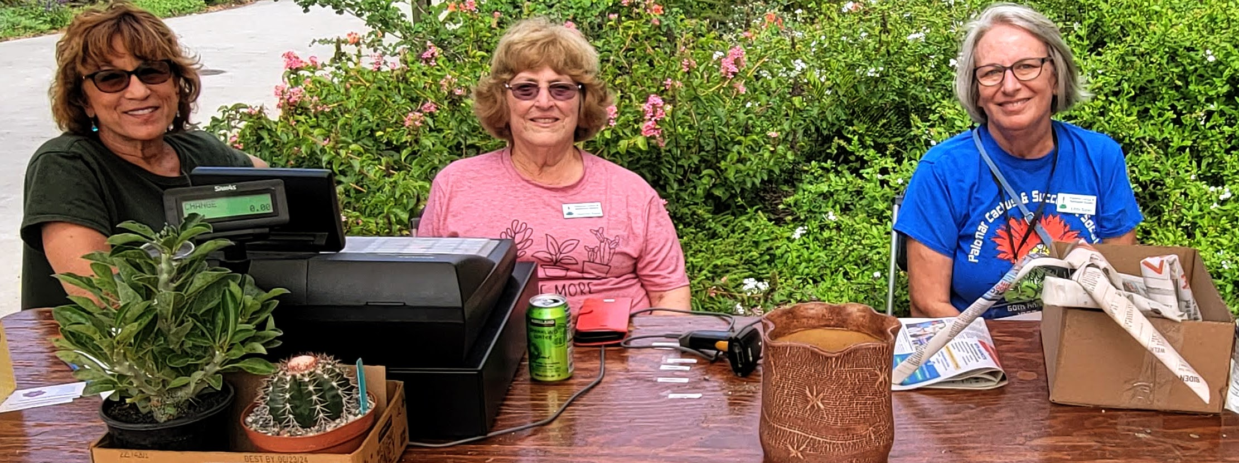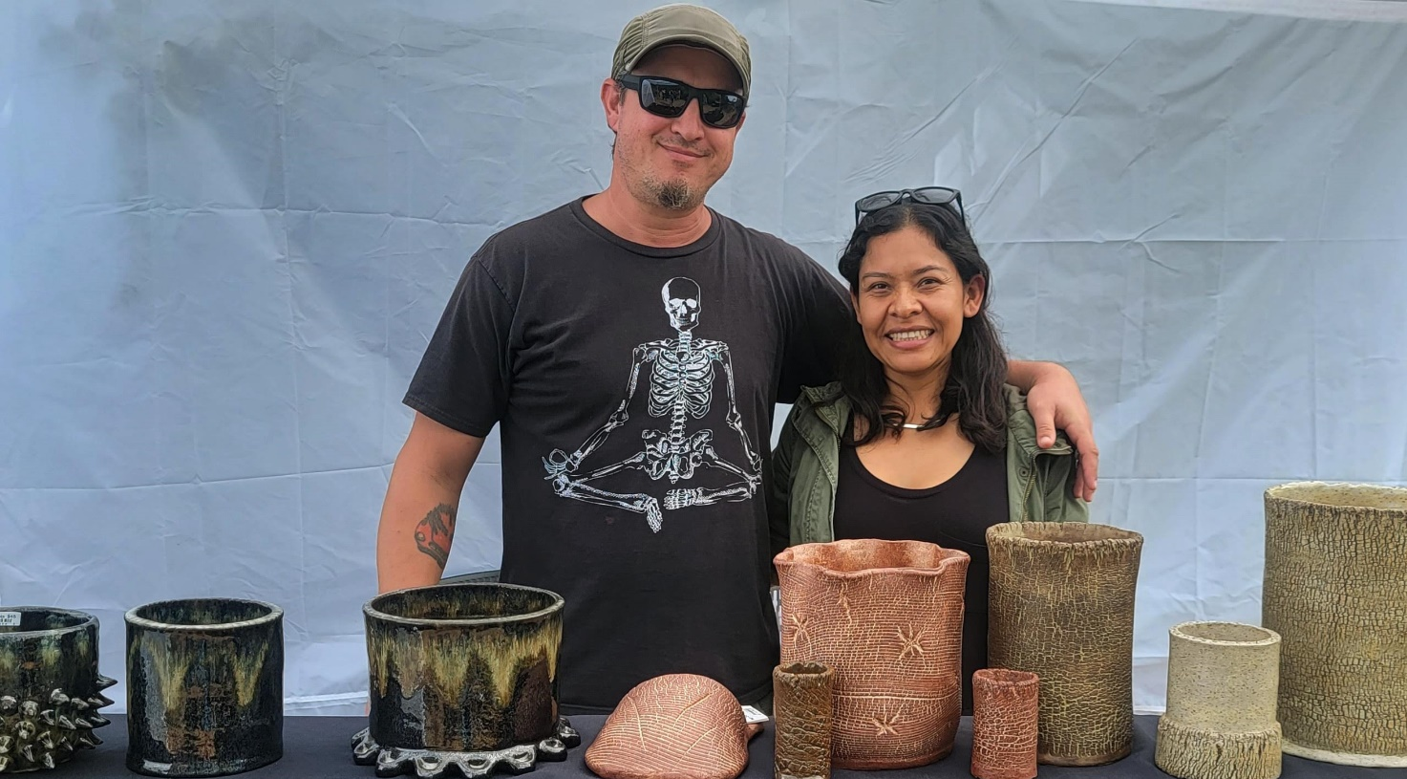
Left to right: Teri Shusterman, Charlyne Barad, Libbi Salvo
Peter and Anabel Hagopian, owners of Root Down Pots.
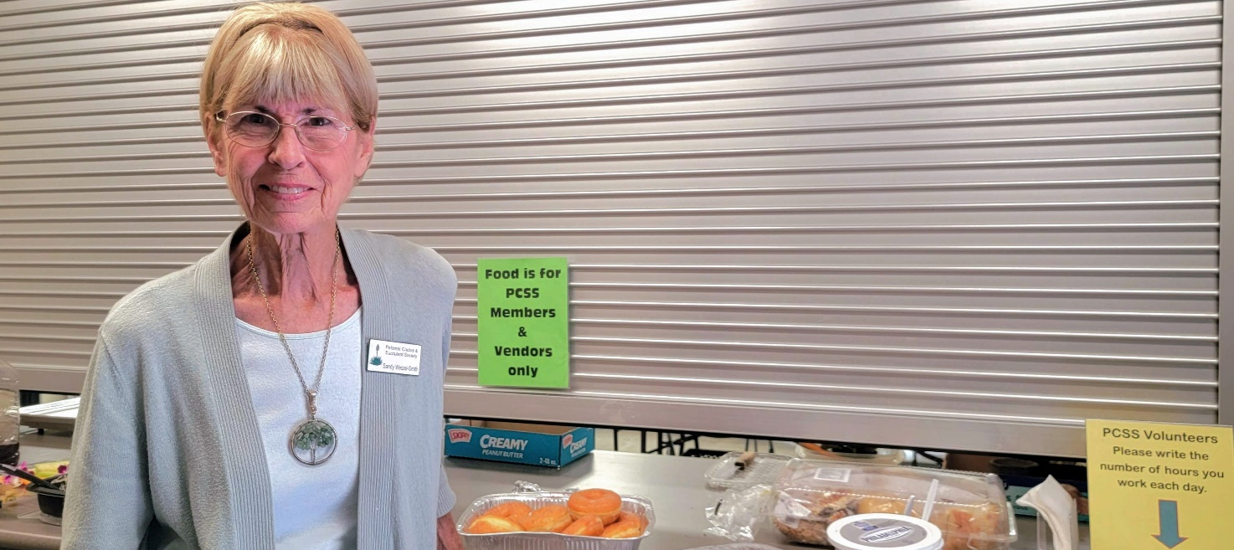
Sandy Wetzel-Smith, Refreshments
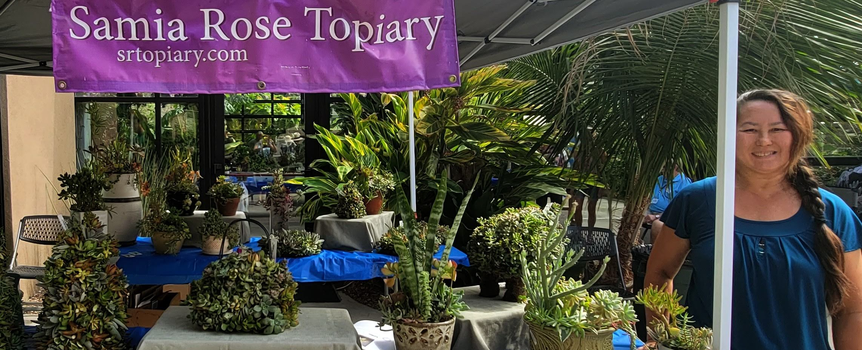
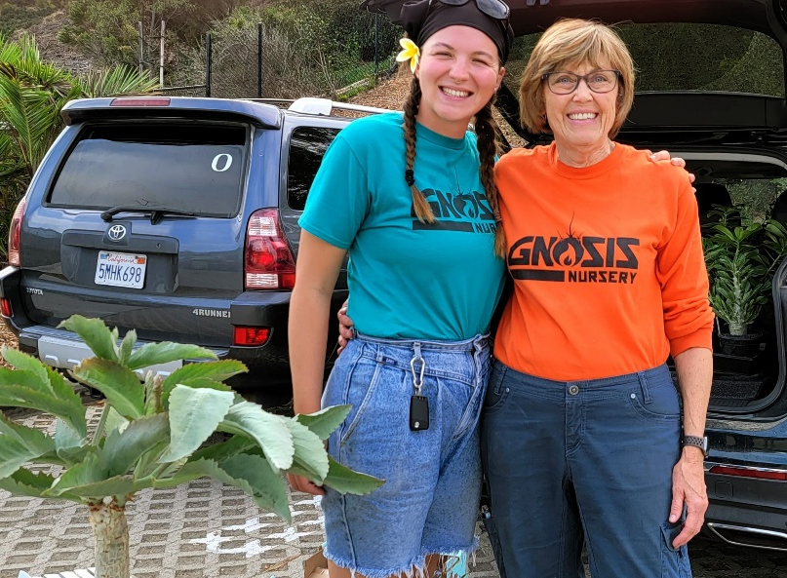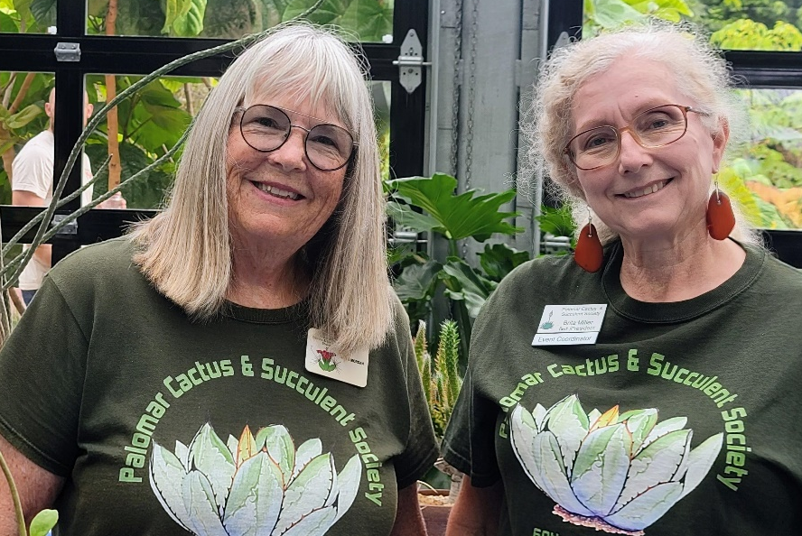
Kaitlyn Long (left) and Jackie Karras
Annie Morgan (left) and Brita Miller

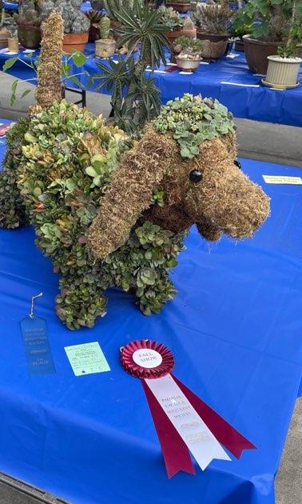
Judge’s Choice: Dog topiary by Pat Hammer.
Russel Ray helping place name tags.
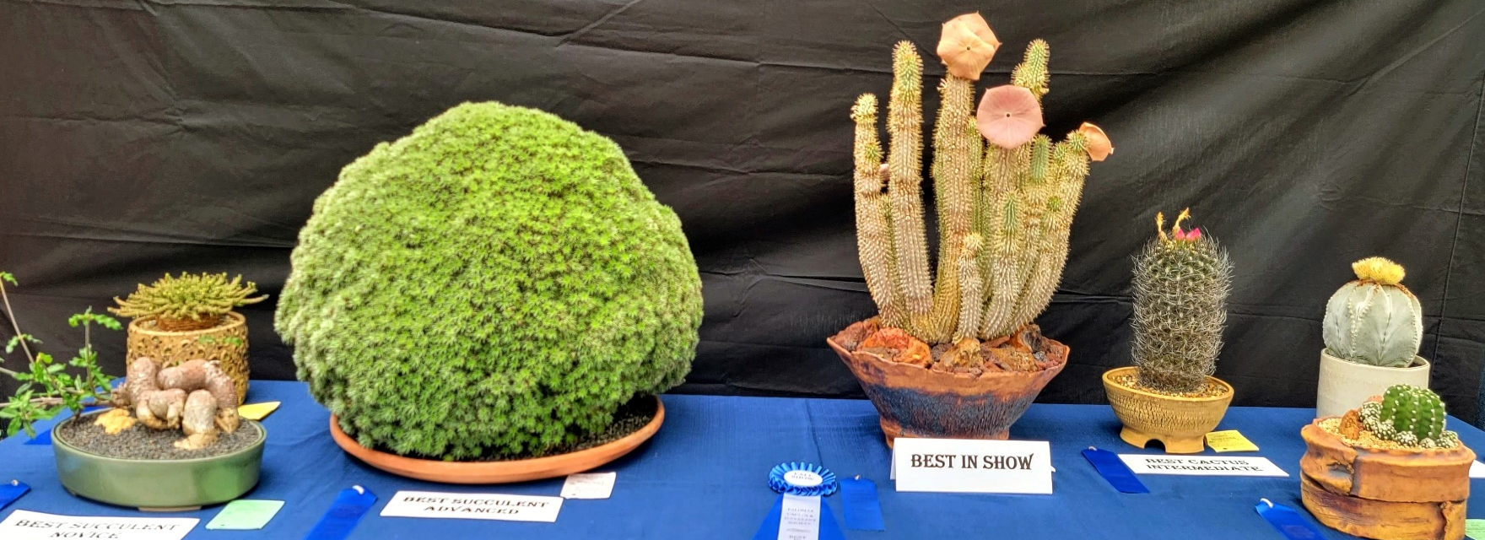
Winner’s Table.

Best Succulent Novice: Joan Herskowitz, Fockea edulis
Best Cactus Novice: Jose Muñoz, Echinopsis subdenudata
Best Succulent Intermediate: Pete & Anabel Hagopian, Euphorbia medusa hybrid
Best Cactus Intermediate: Harold Dunn, Neoporteria (Eriosyce) crispa
Best Succulent Advanced: Robert Kopfstein, Deutercohnia brevifolia
Best Cactus Advanced: Dean Karras, Astrophytum myriostigma
Best in Show: Dean Karras, Hoodia gordonii
Judge's Choice (Dr. Ed Nelson): Mike Nelson, Bursera microphylla
Judge's Choice (Michael Buckner): Pat Hammer, Dog topiary
People's Choice: Peter Walkowiak, Ceraria namaquensis
People's Choice Runner Up (2nd Place): Dean Karras, Hoodia gordonii
People's Choice 2nd Runner Up (3rd Place): Peter Walkowiak, Euphorbia suzannae

2022 FALL SHOW RIBBON WINNERS
Division 1: Cacti
North American Cacti
Category 1 – North American Opuntioids
Novice
1st Michelle Leung Cylindropuntia mamillata ‘Monstrose’
Intermediate
1st Jerome Kahn Pereskia grandiflora
Advanced
1st Russel Ray Opuntia polyacantha ‘Dark Knight’
2nd Russel Ray Opuntia pycnantha
2nd Russel Ray Opuntia sulphurea
Category 2 – North American Arborescent, Columnar, and Shrubby/Sprawling Cacti
Intermediate
1st Jerome Kahn Peniocereus sp.
Advanced
1st John Barkley Peniocereus viperinus
2nd Dean Karras Stenocereus eruca
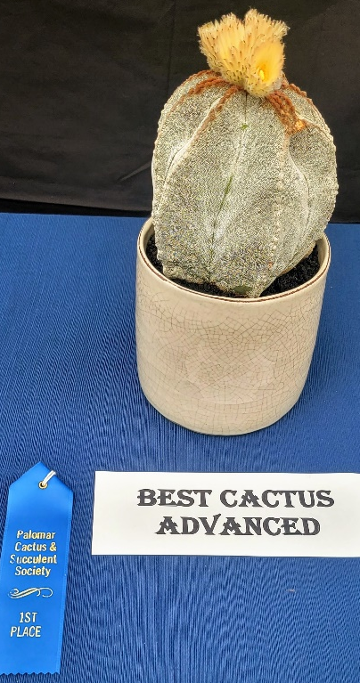
Category 4 – Astrophytum
Intermediate
1st Neila Rybicki Astrophytum sp.
Advanced
1st Dean Karras Astrophytum asterias
1st Dean Karras Astrophytum myriostigma
2nd Dean Karras Astrophytum caput-medusae
Category 5 – Aztekium, Epiphelantha, Obregonia,
Pelecyphora, Strombocactus
Intermediate
1st Lisa Brosseau Obregonia denegrii
2nd Neila Rybicki Obregonia denegrii
Advanced
1st John Barkley Strombocactus disciformis
Category 6 – Coryphantha, Escobaria, Neolloydia, Ortegocactus
Intermediate
1st Harold Dunn Coryphantha retusa
Advanced
1st John Barkley Escobaria tuberculosa
Category 7 – Pediocactus, Sclerocactus, Stenocactus, Thelocactus, Turbinicarpus
Intermediate
1st Lisa Brosseau Turbinicarpus schmiedickeanus
Advanced
1st John Barkley Thelocactus conothelos
2nd John Barkley Thelocactus rinconensis
2nd Dean Karras Turbinicarpus lophophoroides
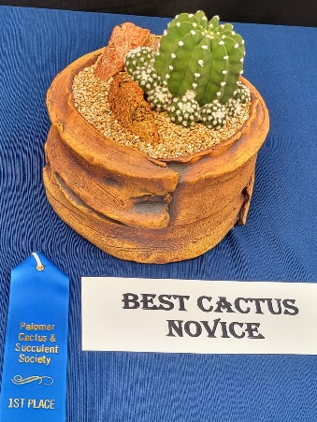
3rd Dean Karras Turbinicarpus saueri ssp. septentrionalis
Category 8 – Echinocereus
Advanced
1st Russel Ray Echinocereus rigidissimus ssp. rubispinus
Category 9 – Echinocactus
Intermediate
1st Neila Rybicki Echinocactus tricuspidatus
2nd Jerome Kahn Echinocactus sp.
Advanced
1st Russel Ray Echinocactus grusonii
2nd Dean Karras Echinocactus texensis
2nd Russel Ray Echinocactus grusonii var. albispinus
3rd Russel Ray Echinocactus texensis
Category 10 – Ferocactus, xFerobergia, Leuchtenbergia
Intermediate
1st Peter Hagopian Ferocactus hamatacanthus
2nd Peter Hagopian Ferocactus chrysacanthus
Advanced
1st John Barkley xFerobergia (F. emoryi x L. principis)
2nd Dean Karras Ferocactus sp.
3rd Russel Ray Ferocactus latispinus

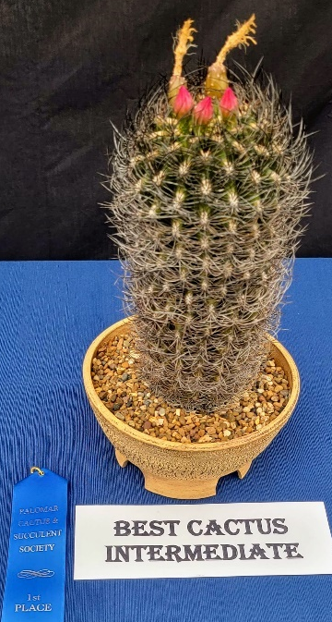
Category 11 – Cochemiea, Mammillaria (hooked spines)
Intermediate
1st Harold Dunn Mammillaria bombycina
Advanced
1st Lorie Johansen Cochemiea setispina
1st Russel Ray Cochemiea setispina
2nd Russel Ray Mammillaria prolifera
3rd Russel Ray Mammillaria bombycina
Category 12 – Mammillaria (straight spines), Mammilloydia
Novice
1st Liz Rozycki Mammillaria vetula
Intermediate
1st Steve Rybicki Mammillaria compressa
Advanced
1st Russel Ray Mammillaria parkinsonii
1st Dean Karras Mammillaria karwinskiana
2nd Russel Ray Mammillaria compressa
2nd Russel Ray Mammillaria spinosissima ssp. pilcayensis
2nd Russel Ray Mammillaria plumosa
2nd Russel Ray Mammillaria senilis
2nd Russel Ray Mammillaria sp.
3rd Russel Ray Mammillaria sp.
3rd Russel Ray Mammillaria albilanata
Category 13 – Melocactus
Intermediate
1st Peter Hagopian Melocactus warasii
Advanced
1st Dean Karras Melocactus azureus
Category 14 – South American Opuntioids
Intermediate
1st Jerome Kahn Tephrocactus articulata
Advanced
1st Steve Salley Maihueniopsis bonnieae
2nd John Barkley Austrocylindropuntia vestita
Category 15 – South American Arborescent, Columnar, and Shrubby/Sprawling Cacti
Intermediate
2nd Sherman Blench Trichocereus bridgesii f. monstruosa
(short joined type)
2nd Charlyne Barad Trichocereus thelogonus crest
2nd Sherman Blench Pilosocereus pachycladus
Advanced
3rd Russel Ray Cereus hankeanus
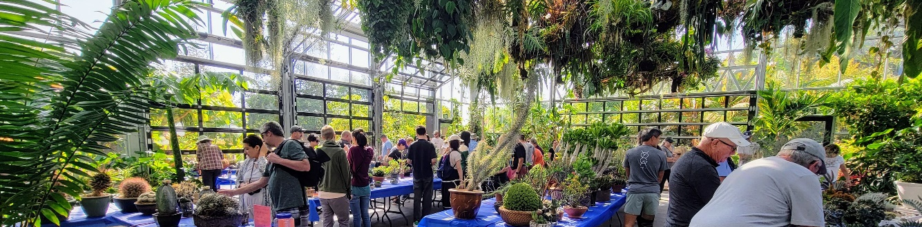
Category 16 – Acanthocalycium, Denmoza, Echinopsis, Lobivia, Matucana, Oroya
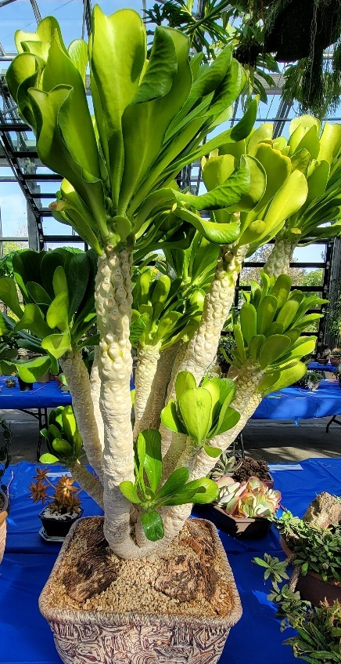
Novice
1st Jose Muñoz Echinopsis subdenudata
Intermediate
1st Jerome Kahn Echinopsis sp.
Advanced
1st John Barkley Lobivia longispina
1st Russel Ray Echinopsis formosa
2nd Russel Ray Echinopsis spachiana
Category 17 – Austrocactus, Copiapoa
Advanced
1st Dr. Cactus Copiapoa dealbata
1st Dr. Cactus Copiapoa columna-alba
2nd Lorie Johansen Copiapoa cinerea
2nd Corona Cactus Copiapoa laui
3rd Steve Salley Copiapoa tenuissima
Category 20 – Eriosyce
Intermediate
1st Harold Dunn Neoporteria crispa
Advanced
1st Dean Karras Eriosyce senilis var. multicolor
2nd Russel Ray Eriosyce senilis
Category 21 – Gymnocalycium
Intermediate
1st Peter Hagopian Gymnocalycium monvillei
2nd Peter Hagopian Gymnocalycium netrelianum
Advanced
1st Dean Karras Gymnocalycium horstii
2nd Dr. Cactus Gymnocalycium riograndense
3rd Russel Ray Gymnocalycium saglionis
Category 22 – Rebutia, Sulcorebutia
Advanced
1st John Barkley Rebutia sp.
2nd John Barkley Rebutia mentosai
3rd John Barkley Rebutia sp.
Category 23 – Parodia
Novice
1st Jose Muñoz Parodia chrysacanthium
Advanced
1st Russel Ray Parodia pencillata
2nd Russel Ray Parodia scopa
Category 24 – Epiphytic Cacti
Intermediate
1st Jerome Kahn Epiphyllum sp.
2nd Lois Walag Rhipsalis ewaldiana
Advanced
1st Moni Waiblinger Epiphyllum guatemalense f. monstrose ‘Curly Locks’
2nd Moni Waiblinger Rhipsalis cereuscula

Category 26 – Crested & Monstrose Cacti
Novice
1st Pat Hammer Cereus forbesii monstrose ‘Ming Thing’
Intermediate
1st Patti Nelson Mammillaria gracilis ‘Arizona Snow Cap’
3rd Charlyne Barad Cereus forbesii monstrose ‘Ming Thing’
Advanced
1st Mike Nelson Cereus crest
1st Dr. Cactus Copiapoa tenuissima f. monstruosa
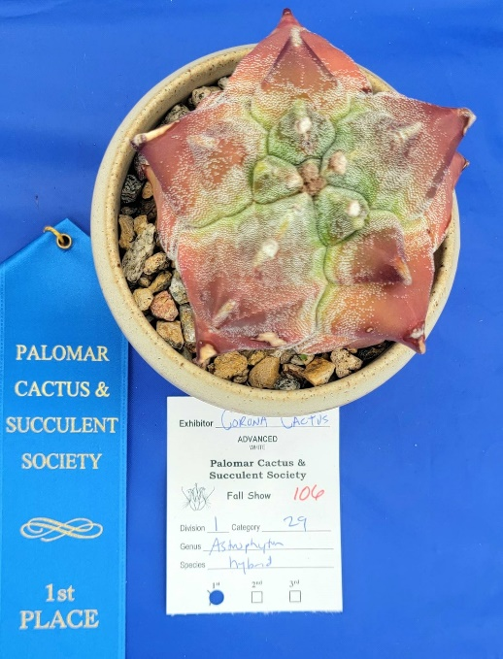
Category 29 – Cacti, seed grown by exhibitor
Advanced
1st Dean Karras Turbinicarpus jauernigii
1st Corona Cactus Astrophytum hybrid
Division 2: Non-Cacti Succulents
Family: Aizoaceae (Mesembruanthemaceae)
Category 30 – Living Stones
Intermediate
1st Pauline Wong Pleiospilos compactus
2nd Peter Hagopian Gibbaeum petrense
Advanced
1st Dean Karras Lithops sp.
Category 31 – Schrubby/Sprawling Mesembs
Novice
1st Joan Herskowitz Mestoklema tuberosum
2nd Kaitlyn Long Trichodiadema bulbosum
Intermediate
1st Mike Nelson Trichodiadema bulbosum
1st Botanic Wonders Trichodiadema bulbosum
2nd Dean Karras Trichodiadema densum
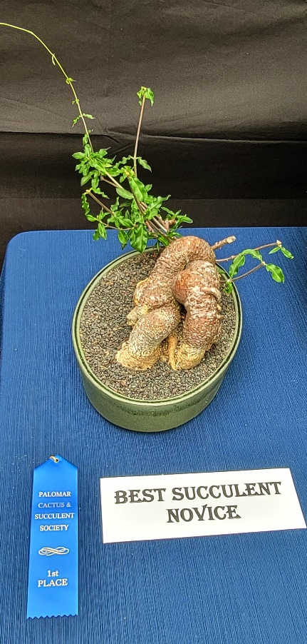
Category 32 – Other Mesembs
Intermediate
1st Pauline Wong Faucaria sp.
Advanced
1st Dean Karras Aloinopsis schooneesii
Family: Apocynaceae
Category 34 – Brachystelma, Fockea, Gonolobusi
Novice
1st Joan Herskowitz Fockea edulis
2nd Pat Hammer Fockea edulis
2nd Gloria Kendall Fockea edulis
3rd Kaitlyn Long Fockea edulis
Intermediate
2nd Jerome Kahn Fockea edulis
Advanced
1st Moni Waiblinger Fockea edulis
2nd Lorie Johansen Fockea edulis

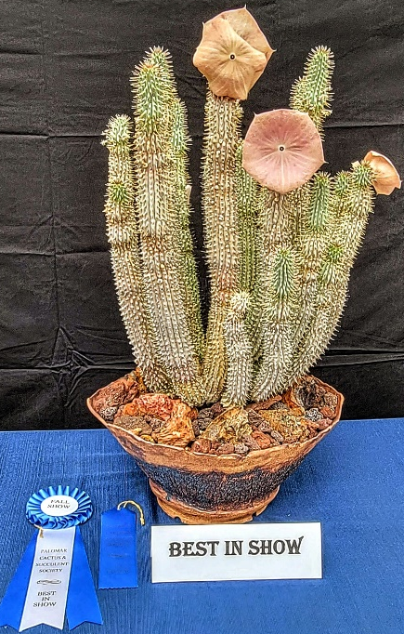
Category 35 – Stapeliads
Advanced
1st Dean Karras Hoodia gordonii
2nd Lorie Johansen Huernia zebrina
2nd Moni Waiblinger Orbea variegata
Category 36 – Ceropegia, Cynanchum, Dischidia, Hoya, Sarcostemma
Advanced
1st Moni Waiblinger Hoya keriii ‘Sweetheart’
Category 37 – Pachypodium
Intermediate
1st Neila Rybicki Pachypodium brevicaule
2nd Neila Rybicki Pachypodium namaquanum
Advanced
1st Steve Salley Pachypodium gracilius
2nd Moni Waibllinger Pachypodium brevicaule
2nd Corona Cactus Pachypodium baronii ssp. windsorii
3rd Dean Karras Pachypodium lealii ssp. saundersii
Family: Aspargaceae
Category 39 – Agave, Beschorneria, Furcraea, Manfreda, Polianthes
Novice
1st Jerome Kahn Agave stricta
Intermediate
1st Patti Nelson Agave potatorum variegate
2nd Patti Nelson Agave applanata ‘Cream Spike’
3rd Peter Hagopian Agave isthmensis
3rd Pauline Wong Agave univittata
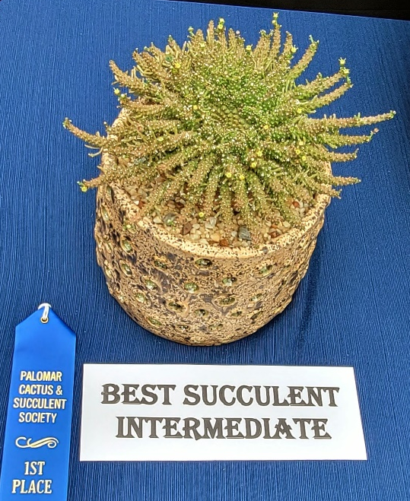
Advanced
1st Moni Waiblinger x Mangave hybrid
2nd Moni Waiblinger Agave leopoldii
Category 40 – Beaucarnea, Calibanus, Dasylirion, Nolina
Intermediate
1st Charlyne Barad Calibanus hookeri
Category 41 – Hesperoyucca, Yucca
Advanced
1st Dean Karras Yucca endlichiana
Category 42 – Old World Bulbs in Asparagaceae
Advanced
1st Robert Kopfstein Ledebouria socialis
1st Lorie Johansen Bowiea volubilis
1st Moni Waiblinger Ledebouria socialis
2nd Moni Waiblinger Drimiopsis dolomiticus

Family: Asphodelaceae
Category 43 – Aloe species, subspecies, varieties, forms
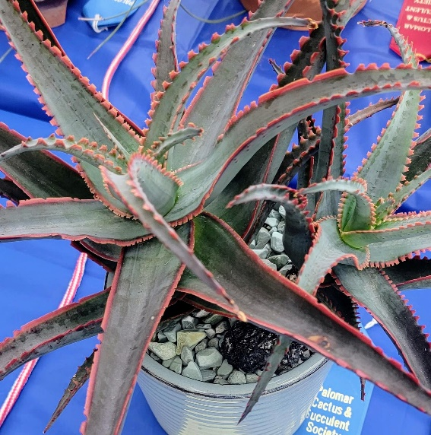
Intermediate
1st Patti Nelson Aloe castilloniaei
1st Patti Nelson Aloe somaliensis
2nd Lois Walag Aloe jucunda
3rd Lois Walag Aloe gariepensis
3rd Lisa Brosseau Aloe ramosissima
3rd Sherman Blench Aloe aculeata
Advanced
1st Dean Karras Aloe peglerae
Category 44 – Aloe hybrids, named cultivars
Intermediate
1st Peter Hagopian Aloe ‘Swordfish’
2nd Lisa Brosseau Aloe ‘Flesh Gordon’
2nd Patti Nelson Aloe brevifolia hybrid
Category 45 – Astroloba, Haworthia
Novice
1st Liz Rozycki Haworthia marumiana var. batesiana
Intermediate
1st Patti Nelson Haworthia comptoniana
Advanced
1st Moni Waiblinger Haworthia hybrid
2nd Moni Waiblinger Haworthia cymbiformis
Category 46 – Gasteria
Intermediate
1st Annie Morgan Gasteria batesiana
Advanced
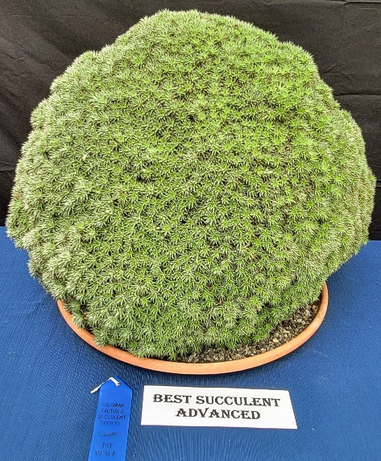
1st Lorie Johansen Gasteria batesiana
Category 49 – Senecio (Caputia, Kleinia)
Novice
1st Joan Herskowitz Senecio articulatus
Advanced
1st Lorie Johansen Senecio macroglossus variegatus
Family: Begoniaceae
Family: Bromeliaceae
Category 52 – Subfamilies Pitcairnioideae & Bromelioideae
Intermediate
1st Jerome Kahn Deuterocohnia brevifolia
2nd Pauline Wong Hechtia sp.
Advanced
1st Robert Kopfstein Deuterocohnia brevifolia
2nd Russel Ray Deuterocohnia brevifolia
2nd Robert Kopfstein Dyckia ‘Painted Lady’

Category 53 – Tillandsia
Advanced
1st Robert Kopfstein Tillandsia tectorum
Family: Burseraceae
Category 54 – Boswellia, Bursera, Commiphora
Advanced
1st Mike Nelson Bursera microphylla
2nd Steve Salley Boswellia sacra
Family: Commelinaceae
Family: Crassulaceae
Category 56 – Adromischus
Advanced
1st Mike Nelson Adromischus marianae ‘Lime Drops’
Category 57 – Subfamily Sempervivoideae
Intermediate
1st Pauline Wong Aeonium ‘Kiwi’
2nd Lois Walag Aichryson x domesticum variegates
Advanced
1st Moni Waiblinger Aeonium crest
1st Moni Waiblinger Aeonium ‘Lily Pad’
Category 58 – Cotyledon, Tylecodon
Advanced
1st John Barkley Tylecodon paniculatus
Category 59 – Crassula
Intermediate
1st Pauline Wong Crassula ovata ‘Gollum’
2nd Pauline Wong Crassula ovata 'Gollum’
3rd Lois Walag Crassula orbicularis
3rd Pauline Wong Crassula ovata ‘Hommel’s Sunset’
Category 60 – Dudleya
Intermediate
1st Lois Walag Dudleya virens ssp. hassei
Advanced
1st Dean Karras Dudleya cymosa
2nd Dean Karras Dudleya greenei
Category 61 – Echeveria – species, subspecies, varieties
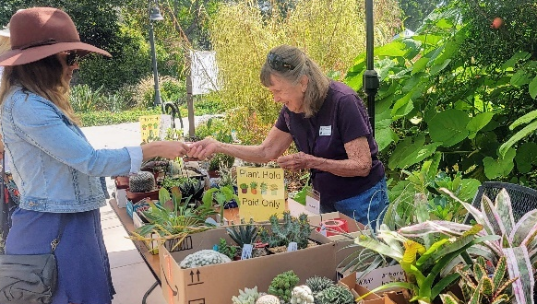
Novice
2nd Liz Rozycki Echeveria sp.
Intermediate
1st Patti Nelson Echeveria agavoides
2nd Pauline Wong Echeveria agavoides
3rd Pauline Wong Echeveria pulidonis
Advanced
1st Dean Karras Echeveria minima

Category 62 – Echeveria – hybrids, cultivars
Novice
1st Michelle Leung Echeveria agavoides ‘Ebony’
Intermediate
1st Pauline Wong Echeveria ‘Mauna Loa’
2nd Pauline Wong Echeveria ‘Lola’
2nd Pauline Wong Echeveria ‘Raindrops’
2nd Pauline Wong Echeveria ‘Blue Curls’
3rd Pauline Wong Echeveria hybrid
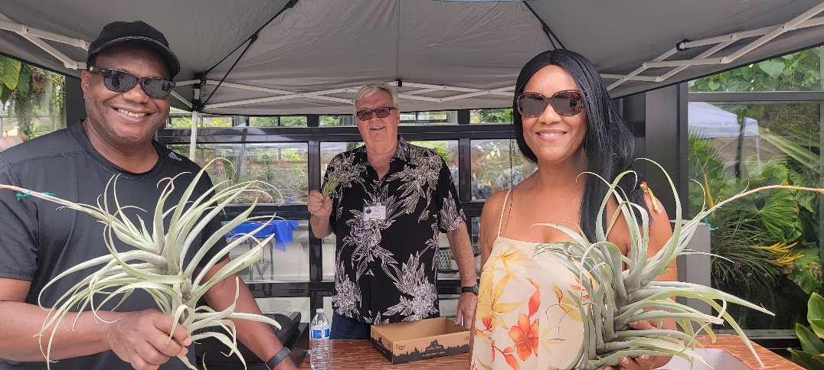
Category 63 – Cremnophila, Graptopetalum, Pachyphytum, Thompsonella, Villadia
Novice
1st Pat Hammer Graptopetalum paraguayense
Intermediate
1st Pauline Wong x Sedeveria hybrid
Advanced
1st Russel Ray Pachyphytum sp.
Category 64 – Kalanchoe (Bryophyllum)
Intermediate
1st Pauline Wong Kalanchoe luciae
2nd Pauline Wong Kalanchoe luciae
3rd Jerome Kahn Kalanchoe beharensis
Advanced
1st Robert Kopfstein Kalanchoe beharensis ‘Fang’
2nd Lorie Johansen Kalanchoe tomentosa ‘Chocolate Soldier’
2nd Lorie Johansen Kalanchoe rhombopilosa
3rd Moni Waiblinger Kalanchoe ‘Taco Leaf’
Category 65 – Subfamily Sedoideae
Intermediate
1st Pauline Wong Sedum nussbaumerianum
Family: Cucurbitaceae
Category 66 – Cucurbita
Advanced
1st Dean Karras Ibervillea sonorae
1st Botanic Wonders Gerrardanthus macrorhizus
2nd Moni Waiblinger Xerosicyos danguyi
2nd Dean Karras Gerrardanthus macrorhizus
Family: Dracaenaceae
Category 67 – Dracaena. Sansevieria
Intermediate
1st Lois Walag Sansevieria suffruticosa
3rd Annie Morgan Sansevieria sp.
Advanced
1st Moni Waiblinger Sansevieria fischeri
2nd Russel Ray Sanseveria hahnii
Family: Didieraceae
Category 68 – Alluaudia, Alluaudiopsis, Calyptrotheca, Decarya, Didierea
Intermediate
1st Annie Morgan Didierea trollii
2nd Jerome Kahn Alluaudia dumosa
Advanced
2nd John Barkley Decarya madagascariensis
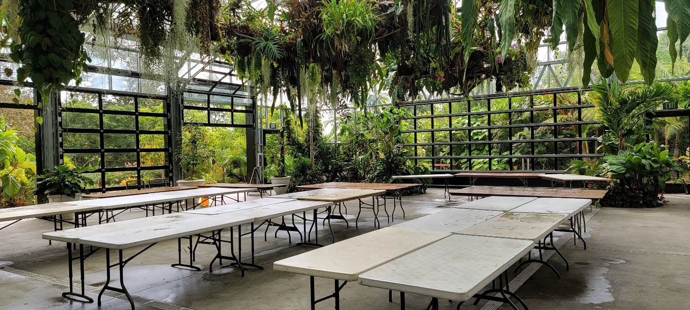
Family: Euphorbiaceae
Category 70 – Euphorbias with no leaves nor spines
Novice
1st Liz Rozycki Euphorbia anoplia
Intermediate
1st Jerome Kahn Euphorbia sp.
Advanced
1st Russel Ray Euphorbia horrida
2nd John Barkley Euphorbia stenoclada
2nd John Barkley Euphorbia sp.
Category 71 – Euphorbias with leaves and spines
Advanced
1st Moni Waiblinger Euphorbia milii variegated
2nd Botanic Wonders Euphorbia milii x decaryi
2nd Russel Ray Euphorbia milii hybrid
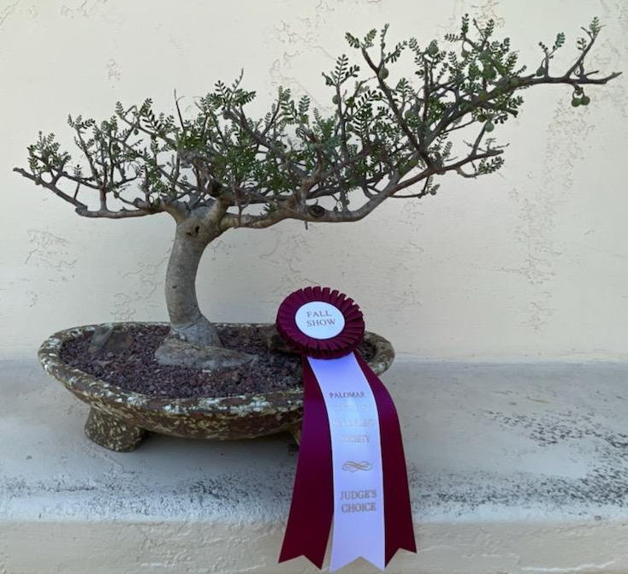
Category 72 – Euphorbias with leaves and no spines
Novice
1st Pat Hammer Euphorbia francoisii
2nd Joan Herskowitz Euphorbia decaryi
2nd Joan Herskowitz Euphorbia tulearensis
Intermediate
1st Pete & Anabel Hagopian Euphorbia ‘Twinkle Twirl’
Advanced
1st Robert Kopfstein Euphorbia decaryi
2nd Mike Nelson Euphorbia globosa
Category 73 – Euphorbias with spines and no leaves
Novice
1st Jose Muñoz Euphorbia zoutpansbergensis
1st Pat Hammer Euphorbia polygona ‘Snowflake’
Intermediate
1st Neila Rybicki Euphorbia columnaris
2nd Harold Dunn Euphorbia polygona ‘Snowflake’
2nd Annie Morgan Euphorbia ‘Zig Zag’
3rd Pete Hagopian Euphorbia leontopoda
3rd Sherman Blench Euphorbia enopla
Advanced
1st Mike Nelson Euphorbia baioensis
2nd Mike Nelson Euphorbia stellispina
3rd Corona Cactus Euphorbia phillipsiae
Category 74 – Medusoid Euphorbias
Intermediate
1st Peter Hagopian Euphorbia medusoid hybrid
Advanced
1st Dr. Cactus Euphorbia suppressa
2nd Mike Nelson Euphorbia suppressa
2nd Botanic Wonders Euphorbia medusoid hybrid
Category 75 – Cnidosculus, Enadenium, Jatropha, Monadenium,
Pedilanthus, Synadenium
Intermediate
1st Jerome Kahn Jatropha sp.
Family: Geraniaceae
Category 76 – Monsonia (Sarcocaulon), Pelargonium
Advanced
1st Dean Karras Pelargonium xerophytum
2nd John Barkley Pelargonium klinghartense
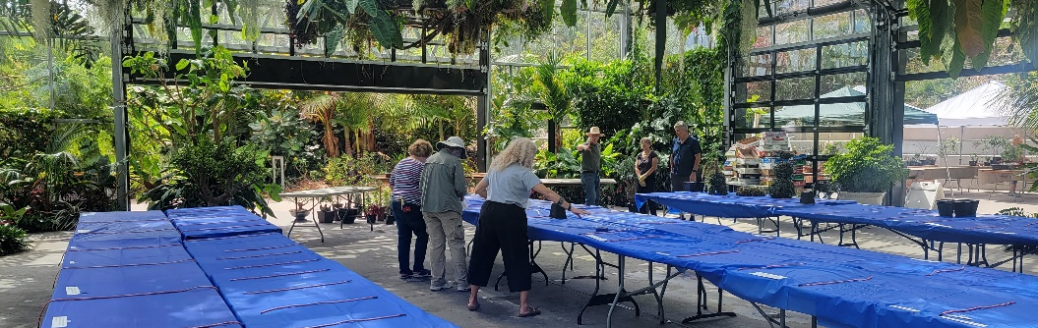
Family: Gesneriaceae
Family: Lamiaceae
Category 78 – Plectranthus
Intermediate
1st Pauline Wong Plectranthus tenuiflorus
Advanced
1st Botanic Wonders Plectranthus ernstii
Family: Moraceae
Category 79 – Dorstenia, Ficus
Intermediate
1st Harold Dunn Dorstenia foetida
Advanced
1st Botanic Wonders Ficus palmeri
2nd Steve Salley Ficus sp.
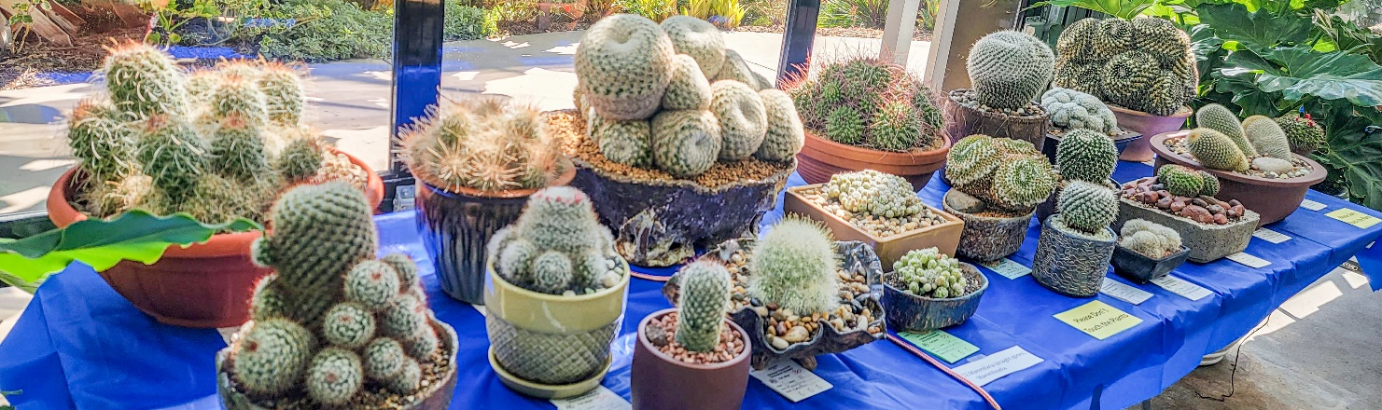
2nd Corona Cactus Dorstenia lavrani
Family: Orchidaceae
Family: Passifloraceae
Family: Piperaceae
Family: Portulacaceae
Category 83 – Anacampseros, Avonia, Ceraria, Cistanthe, Grahamia,
Lewisia, Portulaca, Talinum
Intermediate
1st Lisa Brosseau Avonia buderiana
Family: Vitaceae
Category 84 – Cissus, Cyphostemma
Advanced
1st Robert Kopfstein Cyphostemma uter
Pachycaul Succulents (fat bodies above ground)
Category 85 – New World Pachycauls
Novice
1st Liz Rozycki Pseudobombax ellipticum
Advanced
1st Robert Kopfstein Pachycormus discolor
Category 86 – Old World Succulents
Advanced
1st Mike Nelson Operculicarya decaryi
2nd Russel Ray Operculicarya decaryi
Geophyte Succulents (fat bodies below ground)
Category 87 – Geophytes
Novice
1st Kaitlyn Long Dioscorea elephantipes
Advanced
1st Dean Karras Dioscorea elephantipes
2nd Botanic Wonders Dioscorea elephantipes
3rd Russel Ray Stephania erecta
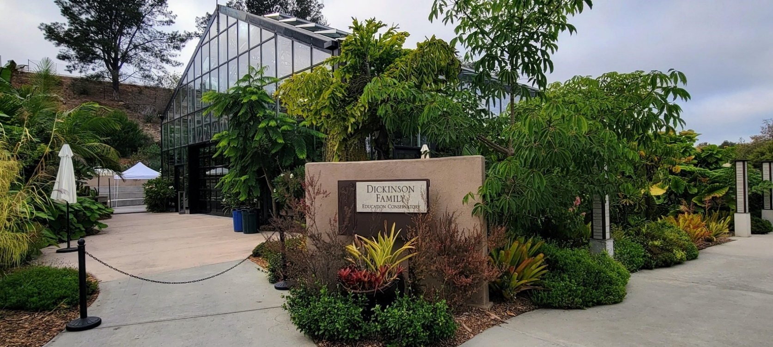
Other Succulents
Category 89 – Variegated Succulents (> 50%)
Novice
1st Jose Muñoz Gasteria batesiana
Intermediate
1st Patti Nelson Aloe sp.
1st Patti Nelson Sansevieria hahnii ‘Golden’
Advanced
1st Corona Cactus Agave victoria-reginae mediopicta
Category 90 – Crested & Monstrose Succulents (> 50%)
Intermediate
1st Harold Dunn Euphorbia lactea crest
Advanced
1st Mike Nelson Leucadendron sp. f. cristata
Category 93 – Succulent Bonsai
Intermediate
1st Lois Walag Oscularia deltoides
Advanced
1st Botanic Wonders Operculicarya decaryi
2nd John Barkley Pelargonium cotyledonis
Category 94 – Genera Not Included in Categories Above
Advanced
1st Dean Karras Welwitschia mirabilis
1st John Barkley Encephalartos trispinosus
2nd Loria Johansen Polyscias fruticosa ‘Snowflake’
Division 3: Other Cacti and/or Succulents
Category 95 – Collections: 5 or more plants, same genus, separate pots
Advanced
1st John Barkley Gymnocalycium
Category 97 – Mature Miniatures, 3 inch pot or less
Novice
1st Jose Muñoz Lenophyllum guttatum
Intermediate
1st Lisa Brosseau Kalanchoe rhombopilosa
Advanced
1st Russel Ray Rebutia narvaecensis
98 – Dish Gardens, natural style
Intermediate
1st Jerome Kahn Dish Garden
Advanced
1st John Barkley Haworthia truncata
1st Russel Ray Mammillaria elongata ‘Kopper King’
2nd Dean Karras Dudley virens ssp. hassei, D. pulverulenta,
D. brittonii
3rd Russel Ray Gynmnocalycium sp.
3rd Russel Ray Spiral spines dish garden
Category 99 – Dish Gardens, anything goes
Novice
1st Samia Rose Topiary Mixed succulents
2nd Samia Rose Topiary Mixed succulents
3rd Samia Rose Topiary Mixed succulents
Advanced
1st Russel Ray Dish Garden
Category 101 – Single Genus, 3 or more species in a single pot
Advanced
1st Russel Ray Astrophytum ornatum cv. Spiral
2nd Russel Ray Stenocactus sp.
Division 4: Artwork
Category 102 – Representational Art
Advanced
1st Russel Ray Aloe striata
1st Russel Ray Mammillaria sp.
1st Russel Ray Deck of Playing Cards

President’s Corner

Robert Kopfstein
In the Palomar Cactus and Succulent Society name, “Cactus” gets top billing. In San Francisco the society there is called the Succulent and Cactus Society, so apparently up north succulents rule. No matter who is considered top dog, both classes of plants exhibit the marvels of the botanic world.
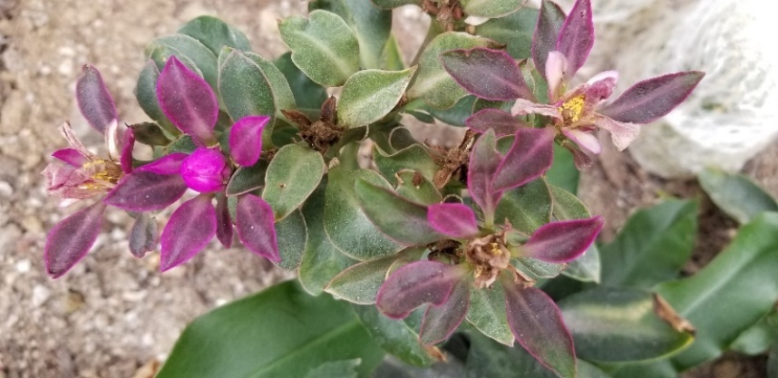
Cactus, however, have demonstrated some truly marvelous adaptations to a world which is in a constant state of flux. They appeared on the scene about 30-40 million years ago, after the continents had separated. This is why they almost exclusively are a plant found only in the Americas; there is nearly always an exception, but more on this in next month’s newsletter.
Cactus also evolved on a post-dinosaur planet that had a major extinction episode which followed the cataclysmic asteroid strike 65 million years ago. The climate during the age of dinosaurs was very wet; it was an age of giant equisetum (horse tails) and ferns. Post asteroid disaster, earth was a much drier place, and it was in this environment that the cactus evolved, along with succulents. To be classified as a cactus, a plant must meet the following criteria:
- The flowers must have many tepals (that is sepals fused with petals).
Many stamens, sometimes numbering in the hundreds.
Many lobes on the stigma; rarely there are only three.
- The stems are herbaceus or woody and contain chlorophyll in order to carry out photosynthesis.
- Branches are modified into areoles with trichomes which are modified plant hairs.
- Leaves are mostly absent, with the exception of the genus Pereskia and Pereskopsis which have both flat and fleshy leaves and spines. The Maihuenia, native
to the Andes, has round leaves, which
also can be found in a succulent called Ceraria pygmaea. Instead of leaves, most cactus species have spines and glochids which are the tiny hairlike spines that stick in your skin and not only itch, but are nearly impossible to remove. The spines and glochids are an effective defense for the cactus against any predator or an unsuspecting gardener who might mistakenly touch what looks like a soft and fuzzy plant seems to invite being fondled.
Like trees, cactus have a cambium layer between the woody interior and the surface tissue. This tissue is composed of thin walled cells that produce a mucilaginous substance that helps to retain the water that is stored there. So essentially the stem of the cactus functions as a food manufacturing site as well as a water storage facility. But the food production—photosynthesis—shuts down if the ambient temperature exceeds 80°F. It is a misconception to think that cacti bask comfortably in 100°+ temperatures; they can tolerate this heat, but to thrive they need cooler conditions.
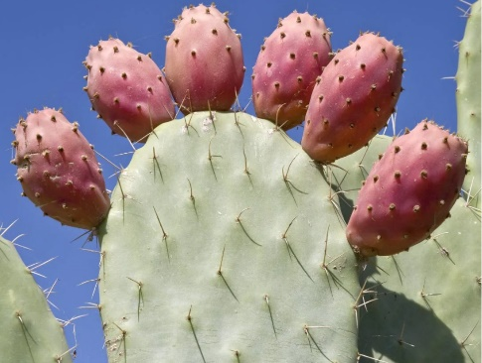
Reproduction in cacti can either be sexual or vegetative. In sexual reproduction, cactus flowers are pollinated by bees, birds, moths, bats, or wind. Seed dispersal usually is done by animals which are attracted by the fruit which usually is colorful with numerous small seeds embedded in the sweet flesh. This cactus fruit is also attractive to humans, and it can be found in super-markets under the name “tuna.” If you gather it directly from the plant, beware of the glochids. To peel and process the tuna, I have found that it is best to use tongs to pick the fruit and then swirl it in a five gallon bucket one third full of water for a minute or two; this will eliminate 90% of the annoying glochids. Then, wearing gloves, you can safely peel the fruit.
Opuntia “tuna”
Vegetative reproduction is accomplished by offsets (think of the multiple “buttons” produced by lophophora) or by fragment-ation (think of the cholla pieces that cling tenaciously to anything or anyone they touch).
Almost 100% endemic to the new world, cactus can be found as far north as Alberta and British Columbia in Canada to as far south as southern Argentina and Chile. There are currently 139 genera and about 2000 species, give or take; the taxonomy lumpers and splitters never rest. Almost all cacti are terrestrial except for Epiphyllum, Rhypsalis, and Shlumbergera which grow epiphytically. The greatest number and variety can be found in the United Mexican States (the official name of Mexico). The exception to the rule that cacti are strictly of the new world is the genus Rhypsalis, which is native to East Africa, Madagascar, and Sri Lanka, with a variety of species growing in each locale.
The uses of cactus are legion:
- In the U.S. probably the most common use is for ornament in our gardens whether outdoors in warmer areas or indoors in the snowbelt.
- Food—Opuntia, de-spined and diced, becomes nopalitos. Sauteed it is delicious when added to scrambled eggs or the nopal can be added to quesadillas, tacos, chili, or tamales.
- Fodder—In times of severe drought when there is little to no forage for livestock, ranchers using blow torches will burn off the spines of prickly pear cactus and feed the singed pads to the desperate animals.
- Hallucinogens—For many centuries, peyote and San Pedro cactus have been used for native American religious ceremonies. More recently, these cacti
also have served for what is termed “recreational” purposes.
- Medicines—Opuntia can be used to treat diabetes, high cholesterol, obesity, hangovers, and colitis because it has antiviral and anti-inflammatory properties. Cactus juice is excellent as an antioxidant, contains electrolytes, and is food for hydration. The juice, like aloe vera, is a useful skin care lotion.
- Making traditional adobe bricks—
The mucilage in opuntia pads is a key ingredient, along with clay and straw, in the manufacture of classic adobe bricks. It acts as a binder for the other ingredients.
Because of their unique niche in the world of plants, cacti are globally popular. Outside of the Americas, they are highly coveted for their exotic and decorative appeal, and specimens can fetch handsome prices. To many of the uninitiated, just about any plant with spines like euphorbias, aloes, agaves, and ocotillos,
is a “cactus”; this is because the cactus family, with its distinctive spines, has become iconic. It is even a key component of the image on the national flag of Mexico (an eagle holding a snake perched on an Opuntia).

2022 MEETING SCHEDULE
Date Speaker and Topic Plant of the Month
October No meeting
November 19 Ron Parker Tephrocactus
Chasing Centuries: Ancient Anthropogenic
Agave Cultivars of Arizona
December 17 Holiday Party - Moni’s Clubhouse

Palomar Cactus & Succulent Society
The North San Diego County C & S Club!
MEMBERSHIP FORM
Click here for a printable form:
PCSS-Membership-Form-Rev-10-1-22.pdf
Palomar Cactus & Succulent Society
Board of Directors
Robert Kopfstein - President president@palomarcactus.org 760-726-8300 no texts
Don Nelson - Vice-President
Brita Miller - Past President, Meeting Set-Up
Teri Shusterman - Treasurer
Moni Waiblinger - Secretary
Charlyne Barad - Show Chair, Member at Large
Lorie Johansen - Member at Large, Guest & New Member Ambassador, Plant of the Month Articles
David Buffington - Member at Large, Brag Points
Dean Karras - Show Chair
Other Volunteers
Russel Ray - Newsletter Editor russelrayphotos@gmail.com or text 619-341-0173
Richard Miller - Membership - membership@palomarcactus.org
Annie Morgan - Website and Facebook info@palomarcactus.org
Dean Karras - Program, Plant Expert, Instagram gnosisnursery@gmail.com
Dennis Miller - Cash Register at Monthly Meetings
Sandy Wetzel-Smith, Bruce Barry – Refreshments
Barbara Raab - Librarian
Kevin Smith - Brag Table & room setup/takedown, Library book transportation
Francis Granger - Guest & New Member Ambassador
Brian Magone - Exchange Table
Russel Ray - Photographer, Website, AV
Julie Kort - Name Tag Drawing Plants

Great Moments in Optiks

Stan Yalof

We have Newton and the reflecting telescope, 1668; Lippershey and Galileo improved the refracting scope; Dutch scientist Antoine van Leeuwenhoek made the first microscope in 1617; Clorela bacteria created oxygen photosynthesis,and 1 BYA; and Lithops and stone plants like Fenestraria (Baby-toes) developed focused optics, perhaps 20-40 million years ago.
Let us consider Aizoaceae > Mesembryanthemum > Lithops > Fenestraria:
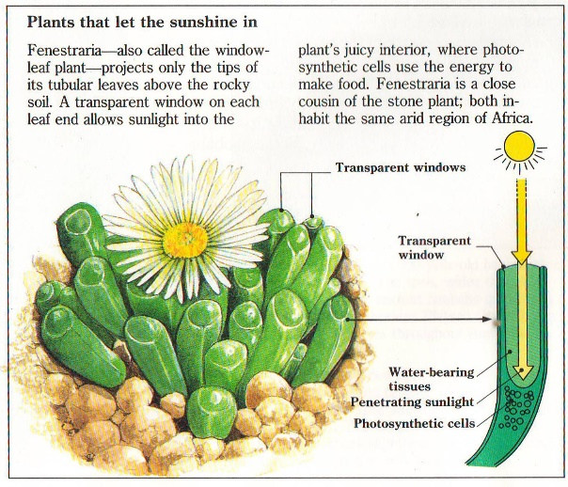
Buried in sand, barely showing, these window plants admit light through a transparency at its tip. This light illuminates the photosynthetic interior, avoiding outside heat and drying winds. Is the tip a simple pane, or perhaps a curved lens, or even nested compound lenses? Has anyone looked into this?
In optics, in order to do the following:
- bring in a range of frequencies (colors)
- extend the angle of collection
- reflect back the collected light
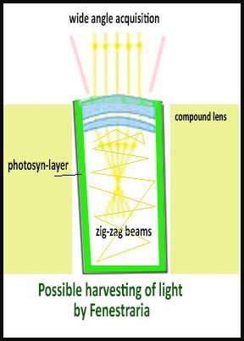
we use a sequence of lenses. For visible light, 400 to 600 nm (nanometers). These lenses would be very-very thin, equivalent to 400-600 x10⁻⁶ mm, actually one quarter of a wave-length thin, or 100 to 150 nm. The outer lens in a stack would have the lowest impedance. With a gradient of impedances, we bring in more light at more wavelengths. The entering light finds the reverse transit difficult, and bounces back. In designing aircraft radar camouflage, I used these methods.
To use an analogy, imagine going into a stadium. The crowded tunnel necks down once or twice but the people flow moves well and stays organized. You get to your seat and find that you forgot your binoculars. The return through the tunnel has a higher impedance, i.e.pushback. You have to work to keep from being reflected.
Cut across an Agave leaf. The top skin admits, the bottom collects light and reflects. Akin to Fenestraria? Plants are tricky.
I recently read in a journal that a research group discovered this concentrator principle to produce one-way light. Nature is way ahead of you guys by millions of years.

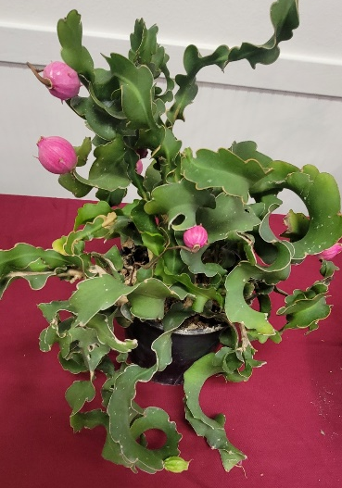
September Brag Plant Winners

NOVICE CACTUS
None
INTERMEDIATE CACTUS
1st - Jim Anderson - Epiphyllum guatemalense monstrose (Pic 1)
ADVANCED CACTUS
1st - Russel Ray - Parodia scopa (Pic 2)
2nd - Moni Waiblinger - Mammillaria gracilis (Pic 3)
1
3rd - Russell Ray - Sulcorebutia rauschi f. violacidermis (Pic 4)
3rd - Russel Ray - Mammillaria prolifera (Pic 5)
2
NOVICE SUCCULENT
1st Deborah Pearson - Euphorbia caerulescens (Pic 6)

INTERMEDIATE SUCCULENT
3
1st - Pauline Wong - Euphorbia milii (Pic 7)
2nd - Libbi Salva - Euphorbia sp. medusoid (Pic 8)
3rd - Kevin Smith - Deuterocohnia brevifolia (Pic 9)
3rd - David Buffington - Fouquieria diguetii (Pic 10)
ADVANCED SUCCULENT
5
4
1st - Mike Nelson - Operculicarya decaryi (Pic 11)
2nd - Mike Nelson - Euphorbia leucadendron f cristata
(Pic 12)
3rd - Dean Karras - Dudleya cymose (Pic 13)
3rd - Moni Waiblinger - Orbea variegata (Pic 14)
6
PLANT OF THE MONTH - NOVICE
7
None
PLANT OF THE MONTH - INTERMEDIATE
1st - David Buffington - Melocactus ernestii ssp. longicarpus (Pic 15)
PLANT OF THE MONTH - ADVANCED
1st - Robert Kopfstein - Melocactus concinnus (Pic 16)
2nd - Dean Karras - Melocactus azure (Pic 17)
11
9

8

12
14

10

13
13
17
16

15
16

